EUROPE

Write about these 10 countries. You can use the Internet.

What is the capital city?
What language do they speak?
What nationality are they?

1. SCOTLAND
capital city
language
nationality
2. ENGLAND | 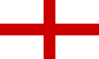
capital city
language
nationality

3. WALES | 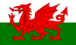
capital city
language
nationality

4. NORTHERN IRELAND
capital city
language
nationality

5. FRANCE | 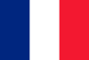
capital city
language
nationality
6. ITALY | 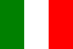
capital city
language
nationality

7. SPAIN
capital city
language
nationality

8. PORTUGAL | 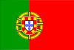
capital city
language
nationality

9. GREECE | 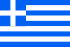
capital city
language
nationality
10. GERMANY | 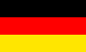
capital city
language
nationality

European capital cities crossword

Fill in the capital city of each of the countries.
 |  |  |  |  |  |  |  |  |  |  |  |  |  |  |  |  |  |  | 1
 |  |  |  | 3 |  |  |  |  |  |  |  |  |  |  |  |  |  |  | V
 |  | 2 | L | O
 |  |  |  |  |  |  | 5
 |  |  | 4 | L |  |  |  |  |  |  |  | 6
 |  |  |  |  |  |  |  |  | 8 |  |  | P
 |  |  |  |  |  | 7 | R |  | M |  | 9
 | 10 | B
 |  |  |  |  |  |  |  |  |  |  |  |  |  |  | 12
 |  |  |  |  |  |  | 11 | B |  |  |  |  |  |  | S
13 | W
 |  |  |  |  |  |  |  | 14 | H
 |  |  |  |  |  |  |  |  |  |  | 15 | D

Across: Down:
2. England  4. Portugal  7. Italy  9. Netherlands  10. Germany | 11. Belgium  13. Poland  14. Finland  15. Republic of Ireland | 1. Austria  3. Norway  5. Switzerland  6. France  8. Spain | 10. Hungary  12. Sweden

